APPLICATION
FOR
EMPLOYMENT

An Equal Opportunity Employer

Applicants are considered for all positions without regard to race, creed, color, national origin, sex, age, disability, marital status, sexual orientation, citizenship or veteran status, or any other protected status under State or Federal law. The City of Greenwood does not discriminate on the basis of disability where such disability is unrelated to the ability to perform the essential functions of the position.

Personal Information

Full Legal Name:
LAST FIRST MIDDLE

Present Address:
NO. STREET CITY STATE ZIP CODE

Have you ever gone by a different name? Yes (specify): No

Phone Number: Email Address:

Position
Position applying for: Salary Requirements:

Availability Full Time Part Time Seasonal Nights/ Weekends

Days NOT available

Were you referred to the City of Greenwood? Yes, Who? No

Have you been previously employed by the City of Greenwood? Yes, When No

Education
 | School Names & Location | Did you graduate? | Course of Study | Degree
High School
College
Graduate School
Business/Trade

Do you hold any certifications and/or licenses? If yes, please list:

Have you served in the Armed Forces? If yes, provide Branch of Service:

Please use the space below to summarize any job-related qualification(s), training, computer
skills, and/or experience:

Employment History (Please begin with most recent employer)
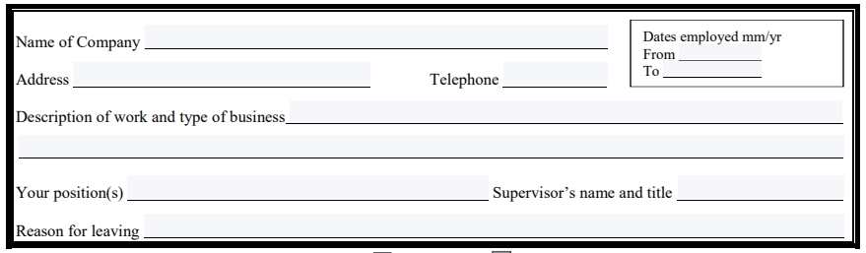May we contact your current supervisor? Yes No
May we contact your current supervisor? Yes No
May we contact your current supervisor? Yes No
May we contact your current supervisor? Yes No
References
Please list three professional references. Include the names, phone numbers, and position(s) of the individuals who are familiar with your work history and experience. Do not list friends, relatives or personal references.

May we contact your present employer? Yes No
Please Read Before Signing
I authorize the City of Greenwood to investigate any of the information contained on my application for employment, including past employment records (excluding salary history), education, medical, driving, bank and credit records, licenses, certificates, references and other facts stated on the application, including criminal background, although I am not obligated to disclose expunged juvenile records of adjudication or arrest. I further authorize all individuals and organizations named in this application to give the City of Greenwood all information relative to such verification. I specifically consent to the disclosure of information which may be covered by a settlement agreement or other “confidentiality” provision entered into with my former employers, and I waive my rights to enforce any such prior confidentiality agreement against my former employer with regard to this disclosure. Additionally, I waive any claim to privacy in such information, consent to the disclosure of information which may be exempt from disclosure by law, and waive any claims I may have to the protection of such information for the limited purposes of investigating and verifying my employment with the City of Greenwood. I waive any right I may have to be notified by any individuals and organizations named in my application for employment prior to the release of any information to the City of Greenwood, including the release of information concerning any disciplinary action taken against me by former employers.
I hereby release and discharge the City of Greenwood and any person or entity from whom any such information is obtained from any liability whatsoever related to the use or disclosure of such information.
I understand that this application is not, nor is it intended to be, a contract of employment. I understand that employment is at-will, meaning that either I or the City can terminate employment at any time for any reason. If hired, I agree to abide by all applicable City rules and regulations as subject to modification by the City.
I hereby certify that the statements I have provided in this application are true and correct to the best of my knowledge. I agree that any misrepresentation or false statement on this application shall be considered grounds for rejecting this application, rescinding a job offer or for immediate discharge if discovered after hire.
Signature of Applicant Date

